Final Project Description Of Used Patterns

Throughout the development of this project, several design patterns were used and/or considered. Some patterns did not work out and were changed during development. Others (such as patterns like factory) were used several times throughout the different pieces of the project. This document will attempt to cover all design patterns that were used, in the final completed project.

Beginning with the party system of the project, three separate design patterns were used. Singleton pattern was used for the party inventory. This allowed for the inventory to remain consistent from many access points, both from the party level and individual character level. Simple factory was also used in the party system. All of the different types of parties shared similar attributes and characteristics; for this reason all of the logic necessary for building a party of any type, was encapsulated within the factory. Iterator pattern was also used within the party system. This allowed outside classes to iterate through that party members contained within the party system, while staying decoupled from the outside classes. Below is the corresponding UML that illustrates these three patterns in the party system:

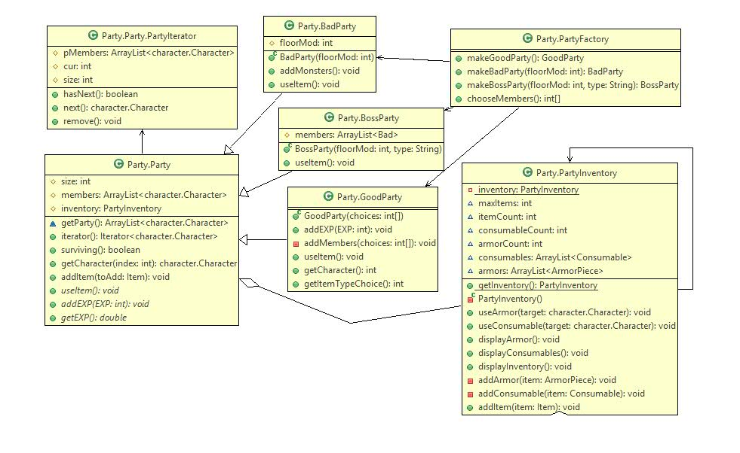

Next, in the character/combat systems Strategy pattern was used to determine attack and defense behaviors. This pattern worked well here, because it was very easy to change attack and defense behaviors in combat, based on a users choice. Additionally this system is easily extensible for new attack and defense behaviors. Below are the corresponding UML diagrams that illustrate this pattern used for both hero character attack and defense behaviors, and also monster character attack and defense behaviors:

